Pacific Islands Hazards Outlook

19 February - 25 February 2026
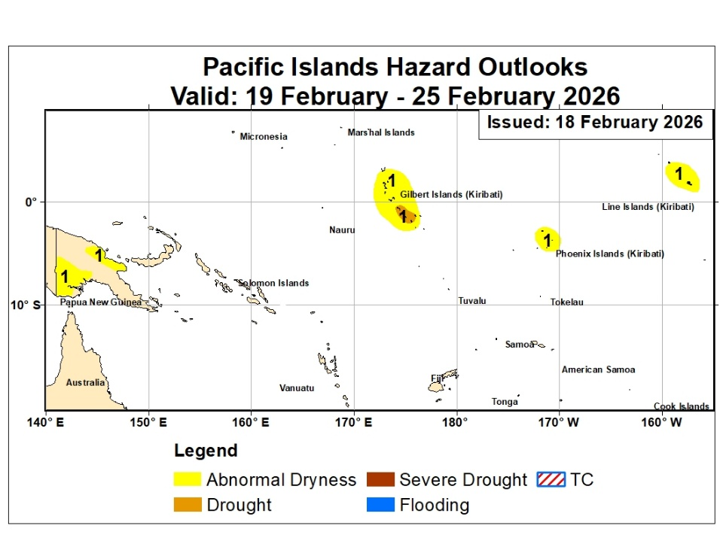
Below to near average rainfall is likely over Central Pacific Region

1. Over the past week, dry conditions were localized but noticeable in several areas. Fiji showed slight rainfall deficits (about 10–50 mm), particularly over Vanua Levu. Southwestern Papua New Guinea also experienced weekly precipitation shortfalls exceeding 50 mm in some locations. Parts of the northwestern Solomon Islands recorded modest deficits (10–50 mm). During the past month, dryness was uneven across the region. Fiji experienced emerging deficits in the eastern, northwestern, and southern areas following a recent rainfall reduction, though overall conditions remained near normal. In Papua New Guinea, persistent dry conditions continued in Morobe, Madang, and the Western and Southern Highlands, with southwestern areas receiving only about 25–80% of average rainfall. Kiribati still showed localized deficits in parts of the Gilbert and Phoenix Islands, although recent rainfall helped reduce shortfalls. Seasonal dryness was most pronounced in Kiribati and southwestern Papua New Guinea. Over the last 90 days, Kiribati recorded widespread rainfall deficits of roughly 80–240 mm, with many locations receiving less than half of normal rainfall and some islands below 25% of average. Southwestern Papua New Guinea also experienced substantial seasonal deficits in some datasets. In the coming week, widespread dry conditions are expected. However, parts of the Kiribati Islands are currently showing rainfall surpluses, but dry polygons are being kept in place due to the expected dryness next week.
2. Wet conditions during the past week were driven mainly by localized storm activity. Papua New Guinea experienced the heaviest rainfall, with intense storms producing totals of up to 200 mm across northern and southern coastal areas, including parts of the Gulf region and nearby islands. Moderate rainfall also affected southern Solomon Islands early in the week. In Kiribati, scattered storms brought moderate rainfall to parts of the northern Gilbert Islands, contributing to short-term rainfall surpluses in northern Kiribati and the Line Islands. Fiji generally received light to moderate rainfall, but overall rainfall remained slightly below average. Over the past month, wet conditions were most evident across the Solomon Islands, where persistent rainfall produced large surpluses exceeding 250 mm in several locations, with some central islands receiving more than double their normal monthly rainfall. Fiji also recorded notable rainfall surpluses earlier in the period, particularly across Viti Levu and Vanua Levu, although these were moderated by a recent lull in precipitation. Parts of Kiribati showed modest rainfall surpluses, while central Vanuatu continued to record above-average rainfall, though with decreasing magnitude. Seasonal wet conditions were widespread across Fiji, the Solomon Islands, and parts of Vanuatu. Fiji recorded very large 90-day rainfall surpluses, exceeding 500 mm across Viti Levu and over 1000 mm in parts of Vanua Levu. The Solomon Islands also experienced sustained wet conditions, with cumulative surpluses exceeding 500 mm in central and northern islands due to repeated storm activity. Northern Vanuatu remained wetter than average, with significant seasonal surpluses in provinces such as Malampa and Penama. In the coming week, above-average rainfall is expected across PNG's southwestern and central regions. The likelihood of rainfall totals exceeding the 80th percentile is low, so significant flood risk is not anticipated during the next week of February 2026.
Hazards Outlook for the Fiji Islands
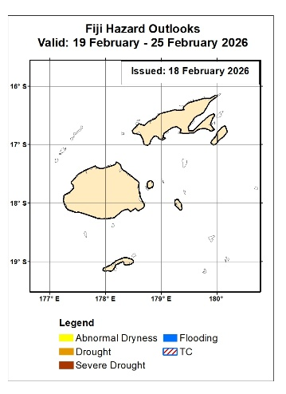
Figure 1: Source NOAA / CPC
Near Average weather conditions are likely over Fiji

During the past week, Fiji experienced generally light to moderate rainfall, with several weather systems approaching early in the period. Despite these events, most islands recorded slight rainfall deficits of approximately 10–50 mm. The largest shortfalls were observed over Vanua Levu, where precipitation remained below average according to satellite-based analyses. Overall, short-term conditions across Fiji were slightly drier than normal, although rainfall activity continued intermittently across parts of the country. Over the past 30 days, rainfall conditions across Fiji were mixed. Persistent precipitation during late January and early February produced moderate rainfall surpluses across much of Viti Levu and Vanua Levu, with cumulative anomalies of roughly 70–100 mm above average. However, a recent lull in rainfall reduced these surpluses and led to the re-emergence of mild deficits across eastern, northwestern, and southern regions, including some outer islands where shortfalls reached about 50–100 mm. Overall, most of the main islands received near-normal rainfall, totaling approximately 80–120% of the climatological monthly average. During the December–January–February period, Fiji remained wetter than average overall. Seasonal rainfall surpluses were substantial across the main islands, exceeding 500 mm in Viti Levu and more than 1000 mm in parts of Vanua Levu. In contrast, northern and southern isolated islands recorded rainfall totals close to normal, with only minor localized deficits. In percentage terms, most of Fiji received about 150–200% of its long-term seasonal average rainfall during the past 90 days. In the coming week, light to moderate precipitation is expected across most of Fiji.
Hazards Outlook for Kiribati
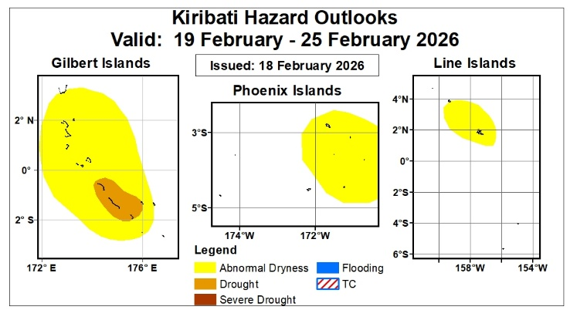
Figure 2: Source NOAA / CPC

Dry conditions expected to persist across Kiribati
During the past week, rainfall across Kiribati was uneven but generally near to above average in several areas. Moderate rainfall associated with scattered, short-lived storms affected parts of the northern Gilbert Islands early in the period, followed by mostly clear conditions across much of the country. Satellite-based analyses indicate rainfall surpluses of approximately 25–100 mm across northern Kiribati and parts of the Line Islands. Overall, short-term conditions were wetter than average in some northern and eastern areas, while other locations experienced relatively dry weather later in the week. Over the past 30 days, rainfall conditions across Kiribati were mixed, with both surpluses and deficits observed. Some stations across the Gilbert and Line Islands recorded cumulative rainfall surpluses of about 10–80 mm. However, localized deficits of up to 80 mm persisted in parts of the Gilbert and Phoenix Islands, including Beru and Canton. Recent rainfall events have helped reduce earlier shortfalls across several islands, resulting in generally near-average conditions across much of the country. During the December–January–February period, Kiribati experienced predominantly drier-than-average conditions. Cumulative rainfall deficits of approximately 80–240 mm were observed across many islands, with several locations receiving less than 50% of their long-term average rainfall. The Phoenix and Line Islands were particularly dry, with seasonal rainfall totals below 25% of normal in some areas. Although occasional rainfall events occurred in early January and early February, seasonal dryness remained widespread across Kiribati. In the coming week, drier-than-average conditions are expected to persist. As a result, the Abnormal Dryness and Drought polygons remain in place over much of the Gilbert and Line Islands.
Hazards Outlook for the Solomon Islands
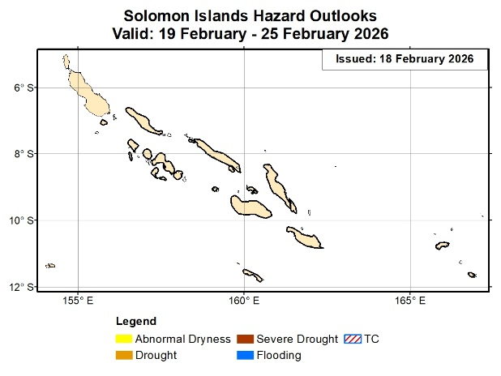

Figure 3: Source NOAA / CPC

The Solomon Islands are likely to experience dry conditions

During the past week, rainfall across the Solomon Islands was generally near to above average, although some localized dry conditions were observed. Mid-week storms brought moderate rainfall exceeding about 25 mm to parts of the southern islands, including San Cristobal, Malaita, and Guadalcanal. Elsewhere, moderate rainfall occurred across the northwestern islands but was insufficient to fully offset short-term deficits, resulting in localized rainfall deficits of 10–50 mm. Overall, conditions were mixed, with wet conditions in the south and slightly drier conditions in some northwestern areas. Over the past 30 days, the Solomon Islands experienced predominantly wetter-than-average conditions. Persistent rainfall and repeated storm activity produced substantial cumulative surpluses across much of the country. Locations in the Western Province, New Georgia, and Guadalcanal recorded rainfall totals more than 250 mm above average, while even the lowest anomalies exceeded about 100 mm above normal. In percentage terms, the central islands received more than 200% of their long-term average rainfall during the period. During the December–January–February period, wet conditions remained widespread across the Solomon Islands. Continued storm activity produced large seasonal rainfall surpluses, exceeding 500 mm in central and northern islands, and ranging between about 100–200 mm above average in southern areas. All monitored locations recorded above-average rainfall, with some sites in New Georgia showing surpluses approaching 600 mm. Overall, most stations received more than 120% of their long-term seasonal rainfall. In the coming week, below-average rainfall is expected across Solomon Islands.
.

